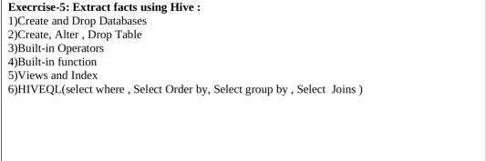

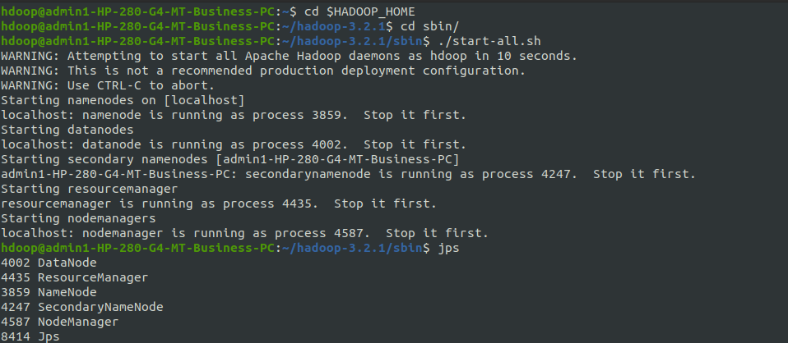

cd $HIVE_HOME

./conf

cd conf

ls

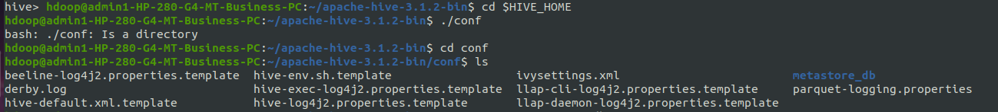

**Dropping the database:**

rm -rf metastore_db



schematool -initSchema -dbType derby

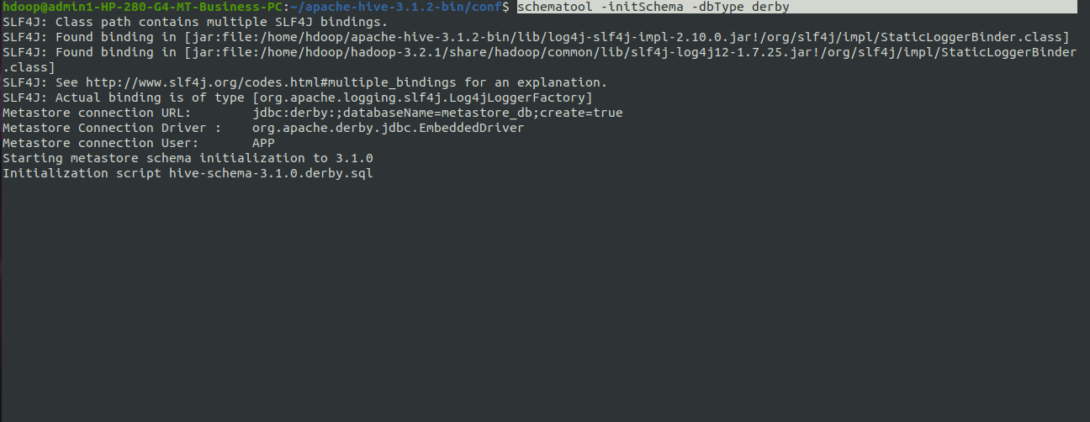

hive

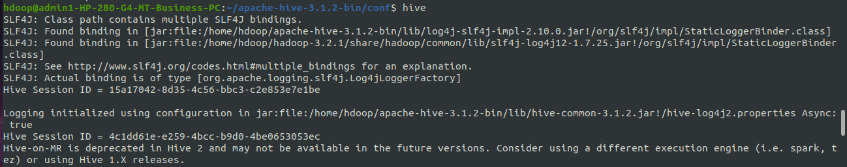

**Creating the database:**

show databases;

create database if not exists salesdb;

use salesdb;

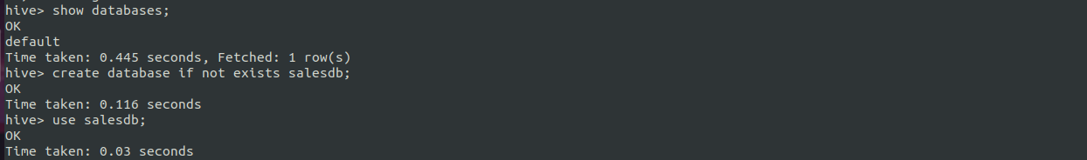

**Creating table:**

create table sales(product string,price int,payment_type string,name string,city string,state string,country string);

desc sales;

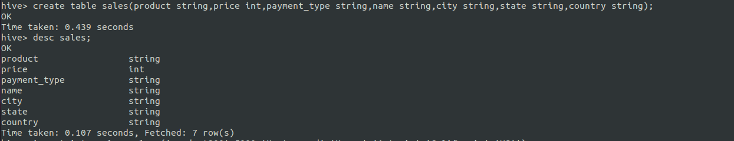

**Inserting values into the table:**

insert into sales values('product200',5000,'Mastercard','Kumar','Astoria','California','USA');

insert into sales values('product201',1000,'Visa','Kamal','Banglore','Karnataka','India');

insert into sales values('product202',3000,'Diners','Koushik','Banglore','Karnataka','India');

insert into sales values('product203',3000,'MasterCard','Harshini','Banglore','Karnataka','India');

insert into sales values('product204',5000,'Visa','Snehitha','Chittor','AP','India');

insert into sales values('product205',6000,'Rupay','Teja','ATP','AP','India');

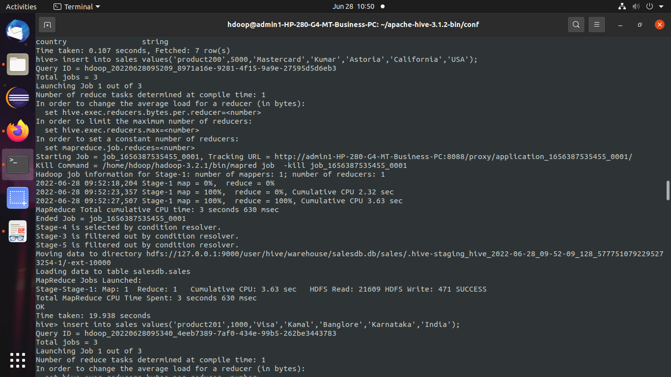

select * from sales;

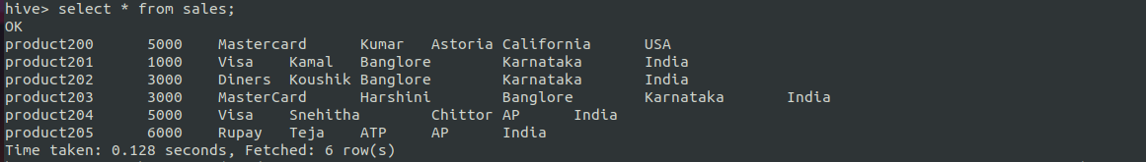

**Dropping the table:**

create table Salet(Product string,Price int,Payment_type string,Name string,City string,State string,Country string)

drop table Salet;



**Alter table:**

alter table sales rename to 1nt19is107_sales;





**3.Built in operators:**

### **Arithmetic Operator in Hive**

select product,name,price+1500 from 1nt19is107_sales;

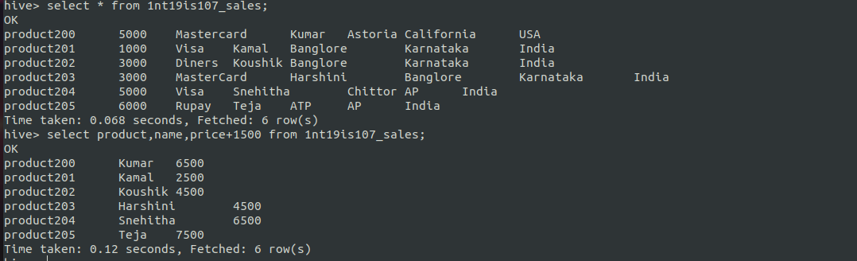

select product,name,(price*10)/2 from 1nt19is107_sales;

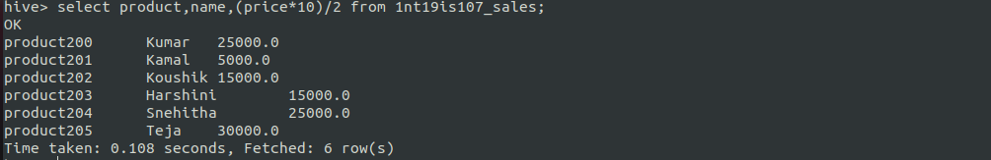

## **Relational Operators in Hive**

select * from 1nt19is107_sales where price>4500

> ;

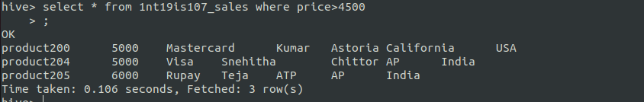

**4.Built in functions:**

**Mathematical Functions in Hive**

select product,name,sqrt(price) from 1nt19is107_sales;

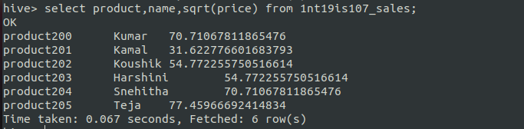

select product,name,floor(price) from 1nt19is107_sales;

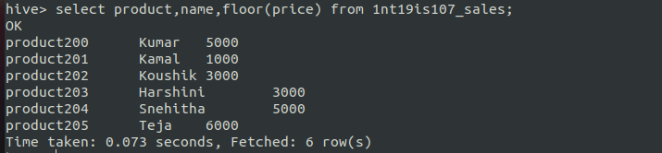

select product,name,cos(price) from 1nt19is107_sales;

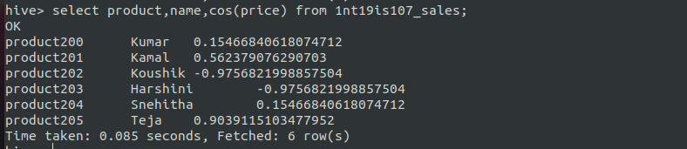

## **Aggregate Functions in Hive**

select max(price) from sales where state='Karnataka';

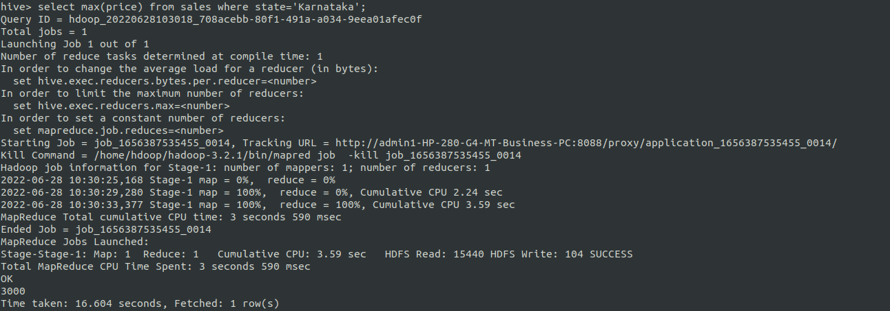

**Other built-in functions**

select product, upper(name) from 1nt19is107_sales;

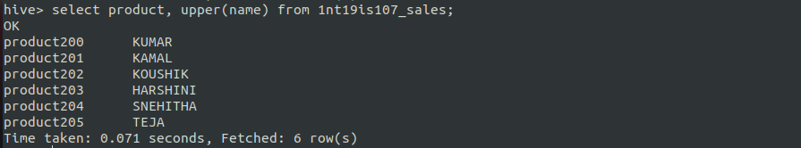

select product, reverse(name) from 1nt19is107_sales;

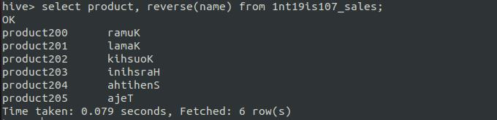

select product, concat(name,state) from 1nt19is107_sales;

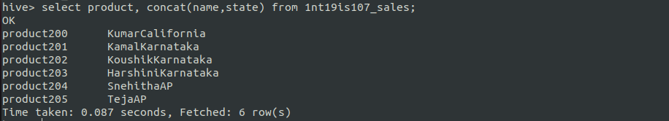

select product, trim(name) from 1nt19is107_sales;

(Removes white spaces from both the ends)

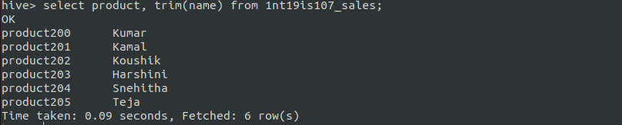

**5.VIEWS:**

create view visa as select * from sales where payment_type="Visa";

select * from visa;

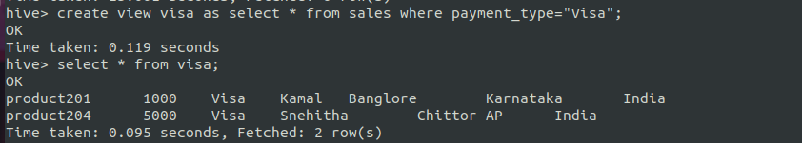

create view master as select * from sales where payment_type='Mastercard';

select * from master;

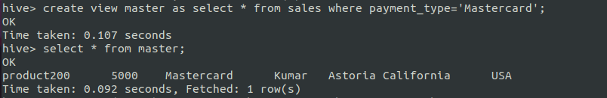

**6.HIVEQL**

**GROUPBY:**

select count(*)as count,country from sales group by country;

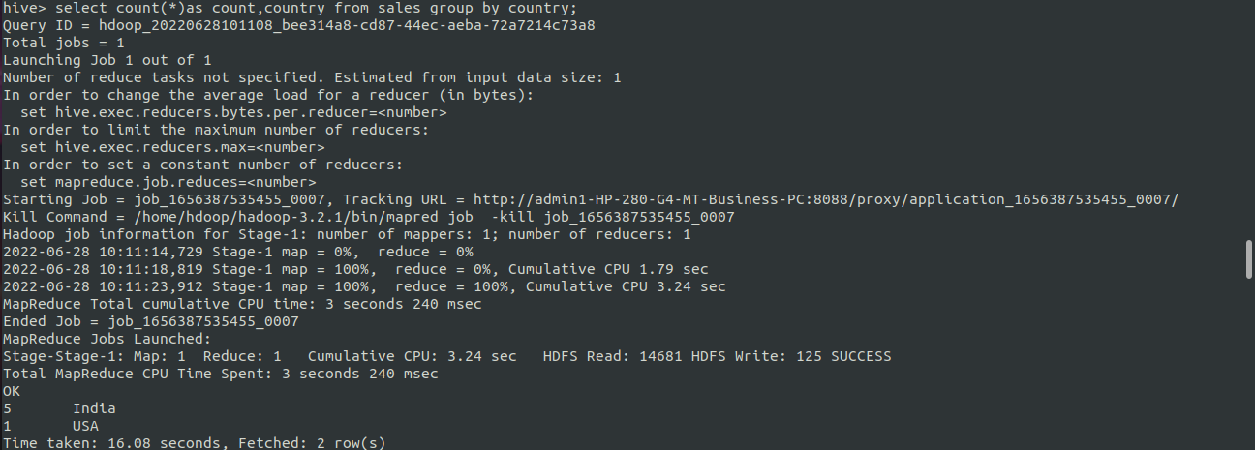

select count(*) as count,state from sales group by state;

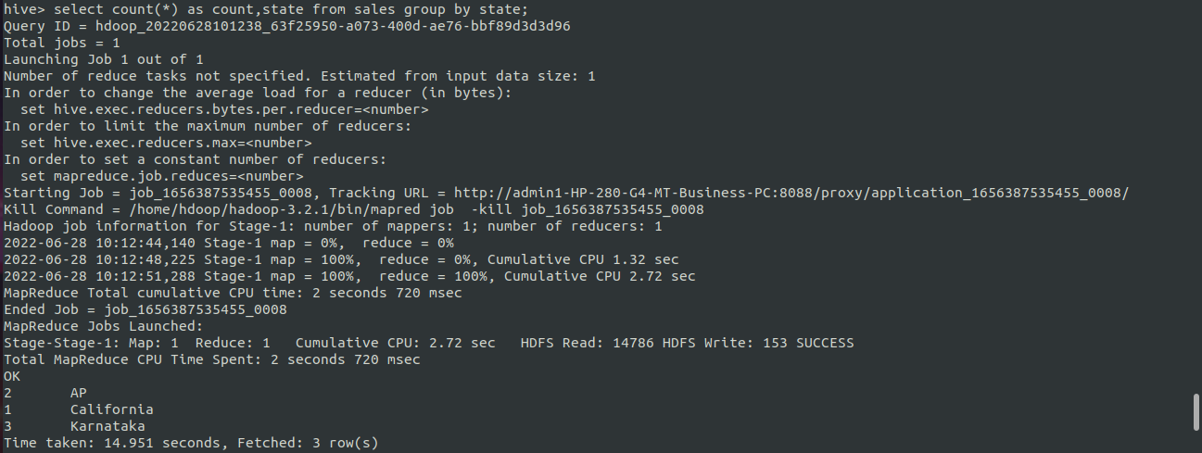

select product,name from sales group by product,name;

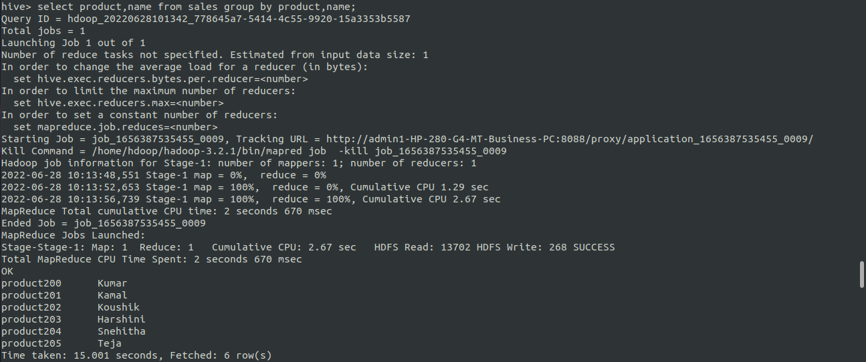

**WHERE:**

select * from 1nt19is107_sales where state="Karnataka";



**ORDERBY:**

select * from 1nt19is107_sales order by price;

